EXERCISE 7
- List the names of 5 youngest employees in the company.
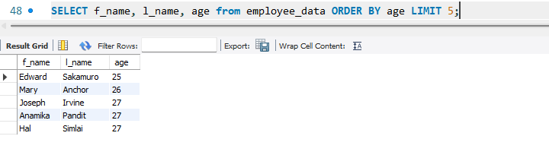
- Extract the next 5 entries starting with the 10 row.
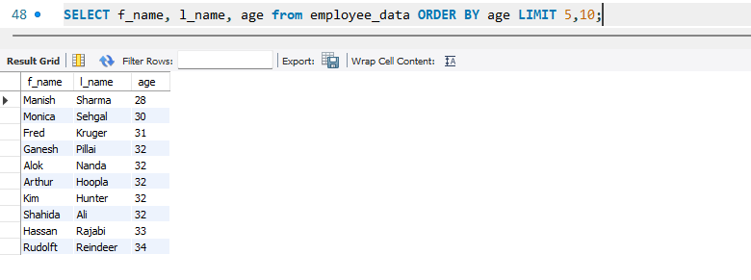
- Display the names and salary of the employee who draws the largest salary.
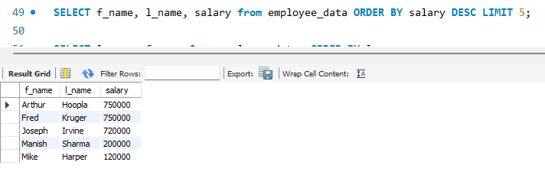
- What does the following statement display?
Select emp_id, age, perks from employee_data ORDER BY perks DESC LIMIT 10;
